Internal Version

Table of Contents

1. Introduction to the CostOut Database of Educational Resource Prices 3

2. Updating Prices 6

2.1. CUPA-HR Surveys (CUPA-HR- Administrators in Higher Education (AHE), Professionals in Higher Education (PHE) and Faculty in Higher Education Salary (FHESS) Surveys): 9

2.2. United States Department of Labor, Bureau of Labor Statistics- The Occupational Outlook Handbook (DoL- BLS- OOH): 14

2.3. United States Department of Labor, Bureau of Labor Statistics- Occupational Employment Statistics Survey (DoL-BLS-OES) 18

2.4. Current Population Survey, Highlights of Women's Earnings (DoL-CPS) 24

2.5. Schools and Staffing Survey (DoE-NCES-SASS) 28

2.6. OECD Education at a Glance Report (OECD-EG) 37

2.7. National Education Association (NEA) 41

2.8. Wage and Hour Division (DoL-BLS) 47

2.9. Additional Notes on Updating Prices 49

3. Updating Benefits 51

4. Formatting Guidelines for the Online CostOut Database of Educational Resource Prices 54

4.1. Saving the Database Files Before Formatting 54

4.2. Deleting Extraneous Cells 56

4.3. Change the database to show values 58

4.4. Delete columns that are not needed 59

4.5. Make sure that the column titles are correct 60

4.6. Additional Information on formatting the workable Excel version of the database 62

4.6.1. Combining three columns to create new “DescriptionPrice” column: 62

1. Introduction to the COSTOUT Database of Educational Resource Prices

To estimate the costs of educational programs, it is necessary to identify all the resources or “ingredients” required to implement the program and to assign prices assigned to each ingredient. The **CostOut Database of Educational Resource Prices** provides around 760 U.S national average prices for personnel and non-personnel ingredients, compiled from over a dozen sources that collect information using regional, local and national surveys. Personnel prices are generally salary amounts reported without benefits, which must be added separately where relevant. Facilities prices in the database are based on new building construction costs, although analysts may prefer to find rental rates for their locality instead. Prices for materials, equipment and other items are generally based on purchase price in the open market. The prices of personnel are often the most important items to consider when estimating the costs of an educational program because they usually account for 70% - 80% of all program costs (Levin & McEwan, 2001).

Only CostOut personnel should update the database to ensure the integrity of data sources. Users may download the database from *CostOut* and add their own prices to their local versions. The database should be updated and uploaded to *CostOut* through the Admin features in the Demo admin account periodically, for example, after the seven survey release dates in February and March, again after the one September survey release date, and again after the five November and December survey release dates.

There are prices provided for four categories of ingredients in the database. These are personnel, facilities, materials/equipment and other inputs.

* Personnel (588 items). These items vary by educational level (e.g., K-12, postsecondary), occupation, education, annual/weekly/hourly wage, full-time/part-time status, years of experience, mean/median salary, date of estimate, and data source.
* Facilities(125 items). These items vary across level of institution, purpose of building, date of estimate, data source, and median sq. ft. for use versus new construction.
* Materials/equipment (34 items). These items vary by the type of equipment.
* Other inputs (9 items). These include items such as average hotel rates, taxi and airfares, per diems, and mileage allowance.

For each ingredient you will find the information shown in Table 1 provided in the database.

Table 1. Fields in CostOut Database of Educational Resource Prices

|  |  |  |
| --- | --- | --- |
| Field | Definition | Example |
| Category | Refers to the category of the ingredient: personnel, facilities, material/equipment, other inputs. | Personnel |
| Ingredient | Name of the ingredient | Teacher |
| EdLevel | Educational level served (Grades K-6, Grades 6-8, postsecondary etc.). This field does not refer to the educational level attained by personnel. | K-12 |
| Sector | This is the sector (public, private, or any) that the price reflects. | Public |
| Qualifications/ experience | These are the qualifications and experience of a personnel ingredient. | Requires bachelor’s degree or equivalent plus 2-3 years’ related experience. |
| Description of Ingredient | The content of the description varies by ingredient. Some ingredients contain information describing the position; others indicate the type of school building. When survey information is not clear, we note any assumptions we have made about the time period over which a salary applies, e.g., 9-month academic year vs. calendar year. | Directs the academic program of the institution. Overall responsibilities typically include academic planning, teaching, research, extensions and coordination of interdepartmental affairs (e.g. Admissions, Registrar, and library activities). Price annualized to 12 months (2080 hours). |
| Mean/Median | Description of the price and whether it is a mean/median or “average” value according to the survey. | Mean |
| DescriptionPrice | This is the category where the Qualifications/experience, Description of Ingredient and Mean/Median categories are combined. This is the column that is visible on the Beta version of the Database. The users only see this column and not the other three separate columns that are there to make it easier to collect information while updating the database. |  |
| Price | Dollar value of the ingredient for the indicated period of time or other unit of measure. | $54,400 |
| UnitMeasurePrice | Unit of measure to which the price applies. | Calendar year |
| YearPrice | Year of the price tag. This will be used when making inflation adjustments to the year in which the user wishes to express costs. | 2014 |
| SourcePriceData | Source of the price, mostly the surveys listed in the index. | DoE - NCES - SASS |
| UrlPrice | URL where the price source can be found. | [http://nces.ed.gov/](http://nces.ed.gov/programs%20/digest/d11/tables/dt11_079.asp)  programs /digest/  d11/tables/dt11_079.asp |
| LastChecked | Date CostOut last checked the source for this price. | Nov ‘14 |
| NextCheckDate | Date CostOut next expects the source to update this price. | Dec ‘15 |
| StatePrice | State to which the price applies. Currently all prices show “All States” as only national average prices or representative prices are in the database, no local prices.* | All States |
| AreaPrice | Whether price is metropolitan/non-metropolitan or applies to all areas. Currently all prices show “All Areas” as only national average prices or representative prices are in the database.* | All Areas |

*\*Note that CostOut allows for these national average prices to be adjusted to reflect different states and metropolitan/non-metropolitan areas.*

This handbook provides guidelines on how to keep the CostOut Database of Educational Resource Prices up to date. The guidelines include information on where, when and how to find prices that are included in the database, as well as how to navigate Excel in order to add new prices into the database.

1. Updating Prices

The CostOut database of prices includes the most recent prices available as of the end of March 2015. Each survey is updated at different times of the year and at different frequencies. In order to check whether the database is providing the latest prices available, refer to Table 2 showing the latest release date and the next release date for each survey. The table also shows the approximate number of prices to check for in each survey as well as whether they are personnel or non-personnel prices. In addition, you can find the URL to the homepage of each survey.

*Table 2. Survey Overview with Release Dates and URLs*

|  |  |  |  |  |  |
| --- | --- | --- | --- | --- | --- |
| **Survey** | **Latest Update** | **Next Update** | **Link to Survey** | **# of Price items (approximate)** | **Estimated Time of Update** |
| **CUPA-HR-AHE: Administrators in Higher Education Salary Survey** | February 2016 | February 2017 | *http://www.cupahr.org/surveys/ahe.aspx* | *Personnel, 14* | *1 hours* |
| **CUPA-HR-PHE: Professionals in Higher Education Salary Survey (previously known as the PSS (Professional Salary Survey)** | March 2016 | March 2017 | *http://www.cupahr.org/surveys/phe.aspx* | *Personnel, 53* | *2 hours* |
| **CUPA-HR-FHESS: Faculty in Higher Education Salary Survey of Four-Year Institutions** | March 2016 | March 2017 | *http://www.cupahr.org/surveys/fhe4.aspx* | *Personnel, 161* | *3 hours* |
| **DoL-BLS-OES: Occupational Employment Statistics** | March 2016 | Spring 2017 | *http://www.bls.gov/oes/home.htm* | *Personnel, 58* | *45 hours* |
| **DoL- BLS- OOH: Occupational Outlook Handbook** | December 2016 | December, 2016 (The economic, employment, and labor force projections are updated every other year; the most recent projections are for 2012—22 and were released on the BLS web site in December 2013. The projections also are published in the Monthly Labor Review at the same time as the release.) | *http://www.bls.gov/ooh/* | *Personnel, 14* | *1 hour* |
| **DoL-CPS: Current Population Survey, Highlights of Women's Earnings** | December 2014 | Unknown (Predicted December 2015) | *http://www.bls.gov/cps/earnings.htm#demographics* | *Personnel, 20* |  |
| **DoL-BLS: Wage and Hour Division** | December  2014 | Predicted December 2016 | *http://www.dol.gov/whd/state/stateMinWageHis.htm* | *Personnel, 2* | *10 mins* |

|  |  |  |  |  |  |
| --- | --- | --- | --- | --- | --- |
| **DoE-NCES-SASS: Schools and Staffing Survey** | November 2013 | November 2016 (mid-2016). Survey collected in 4-year cycles, last survey was for 2011-2012) | *http://nces.ed.gov/surveys/sass/index.asp* | *Personnel, 49* | *Data not issued since last update* |
| **NEA: National Education Association** | May 2016 | Predicted May 2017 | *http://www.nea.org/home/44479.htm* | *Personnel, 45 (only 4 with update release dates)* | *20 mins* |
| **OECD-EG: Education at a Glance** | November 2015 | Predicted November 2016 | *http://www.oecd-ilibrary.org/education/education-at-a-glance_19991487* | *Personnel, 12* | *1 hours* |
| **College Planning and Management Magazine** | February 2015 | Predicted February 2016 | *http://webcpm.com/research/2015/02/college-construction-report/asset.aspx?tc=assetpg* | *Facilities, 15* | *3 hours* |
| **School Planning and Management Magazine** | February 2016 | Predicted February 2017 | *http://webspm.com/research/2015/02/annual-school-construction-report/asset.aspx?tc=assetpg* | *Facilities, 15* | *1.5 hours* |
| **BLS-NCS: National Compensation Survey** | March 2016 | Predicted March 2017 | *http://www.bls.gov/news.release/ecec.toc.htm* | *Benefits Rates, 22* | *1 hour* |
| **National Teacher and Principle Survey (NTPS)** | March 2019 | Predicted March 2020 | *https://nces.ed.gov/surveys/ntps/spotlight.asp* | *Personnel, 76* | *1.5 hour* |

*Note: Update* ***Latest Update*** *and* ***Next Update*** *columns in* ***Table 2: Survey Overview with Release Dates and URLs*** *as you update the prices in the database. This table should be updated at least once a year.*

Take note of the surveys that have the most recent updates and the number of price items we use from them.

Then go to the actual database where there is a column titled “LastChecked” that indicates the latest date a given price was checked for updates (Column N) and a “NextCheckDate” column to show the next expected survey release date (see Image 1). The URL for each survey in the database is generally for the specific survey that provides the related price. If the ingredient is Teacher and the year of the price is 2012, the URL will be for that exact survey and not the homepage of the source.

*Image 1. The Survey Information Columns in the Database*

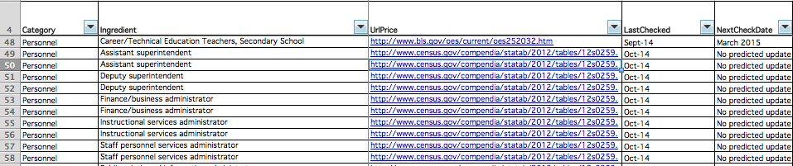

Refer to Table 2 to see whether there has been an update to the survey since the LastChecked date. For example, if you are looking at the database in December 2015, and for a given survey the LastChecked date is March-15 (March 2015), and the latest update on the survey was in November 2015, use the link provided in Table 2 to find the latest version of the survey.

Determine which survey you will be updating. Filter the SourcePriceData column in the database (using the arrow on the column heading, see Image 2) to show only the survey that you choose to update.

*Image 2. Survey Column in the database*

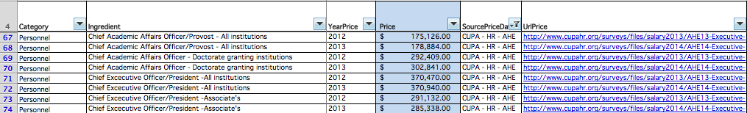

The process of finding price information varies among the surveys. The next section explains the different steps for each survey.

* 1. CUPA-HR Surveys (CUPA-HR- Administrators in Higher Education (AHE), Professionals in Higher Education (PHE) and Faculty in Higher Education Salary (FHESS) Surveys):

For all CUPA-HR surveys (CUPA-HR-AHE/PHE/FHESS) follow the subsequent steps to find the price you want to update. The URLs in Table 2 provide the links to the specific CUPA-HR survey you need.

For example, if you are updating the [Administrators in Higher Education Salary Survey](http://www.cupahr.org/surveys/ahe.aspx) (AHE) click on the link in Table 2 that opens the home page for all AHE surveys. Click on the survey that you want to access. In order to open the page with price information, click on 2015 Survey “Executive Summary.”

For all CUPA-HR surveys, the price information you need is provided under the Executive Summary tab (see Image 3).

*Image 3. Administrators in Higher Education Salary Survey Homepage*

[](http://www.cupahr.org/surveys/files/salary2014/AHE14-Executive-Summary.pdf)

The survey will open on a new page. Go back to the database to see the ingredients taken from this survey. By filtering the “SourcePriceData” in your database, you can see the ingredients that are found in that specific survey.

If, for example, you are looking for “Provost- Associate- All institutions,” then enter “CTRL + F” on your keyboard and type “Associate Provost” at the survey page (see Image 4). This simple keyboard search function will make it easier for you to find the ingredient you are looking for. In this example, the price you need is under the All Institutions column (see Image 4, “*$126,340”)*.

Make sure that you type in at least one key word for the ingredient you are searching for. For example, searching “Associate” will, in most cases, show you several results, including “Associate Provost.” If the position title that you search for does not come up on the survey, try different key words or scroll through the list directly for the position. In some cases, the position title may have been changed or removed since the last update. In order to figure out whether the position has been removed or renamed, refer to the Position Descriptions provided in the survey website. More information on where to find the Position Description page for CUPA-HR surveys will be provided in the next section.

*Image 4. CUPA-HR Survey Price Search Example*

[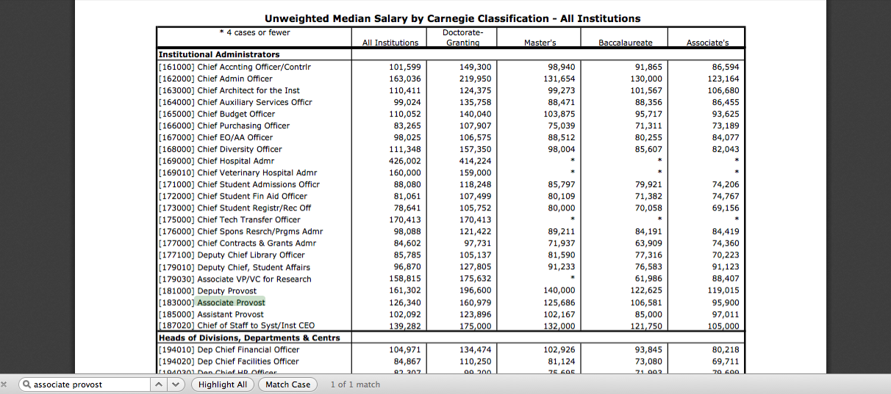](http://www.cupahr.org/surveys/files/salary2014/AHE14-Executive-Summary.pdf)

As summarized in Table 1, each ingredient has information such as Description Price, Mean/Median, Qualifications/experience, etc. in the database, in addition to the price amount. While it is rare that the information about a given ingredient changes every year, it is important to pay attention to these categories while updating a price. You can find Educational Level, Sector and Mean/Median in the survey Executive Summary. You can go back to Image 4 to see where the table indicates Educational Level (Postsecondary institutions) and whether the price estimate is Mean/Median (“Unweighted Median Salary by Carnegie Classification”). As for the StatePrice and AreaPrice columns, put in “All states” and “All areas” since CUPA-HR are national level surveys that report on prices representing all states and all areas.

For information on Description of Ingredient, Qualifications/Experience and UnitMeasurePrice look at the separate URLs provided for Position Description and Worksheet in Table 3.

*Table 3. Where to Find Required Information for Each Ingredient*

|  |  |  |
| --- | --- | --- |
| **Field** | **Where to find it?** | **URL** |
| **Qualifications/ experience** | Indicated in the survey Position Descriptions | *http://www.cupahr.org/surveys/worksheets.aspx* |
| **Description of Ingredient** | Indicated in the survey Position Descriptions | *http://www.cupahr.org/surveys/worksheets.aspx* |
| **UnitMeasurePrice** | Indicated in the survey Worksheet | *http://www.cupahr.org/surveys/worksheets.aspx* |

The next step is to add the new price information to the database.

Find the ingredient you want to update in the database. Make sure that the database is no longer filtered by survey name (all filter functions must be off). Insert a new row below the ingredient you are updating (right clicking on the row below the price you want to update, then “Insert”). As can be seen from Image 5, if you are adding a 2014 price for “Provost- Associate- All Institutions” go to the row showing the most recent price before 2014. Here, it is row 382 showing the 2013 price. Right click on the row below (row 383) to add a new line following the 2013 price (Image 6).

*Image 5. Adding a New Price I*

## Macintosh HD:Users:ipekbakir:Desktop:Screen Shot 2015-03-11 at 10.43.09 PM.png

Image 6. Adding a New Price II

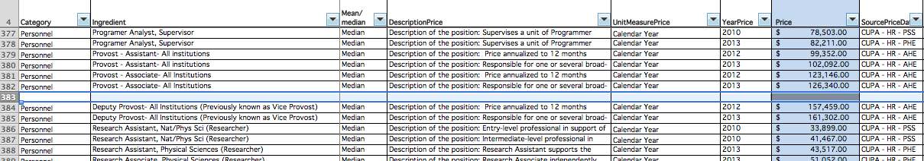

Add a new line for each new price and, in the relevant columns, fill in the information you have found through the steps provided above. In most cases, the Price, YearPrice and SourcePriceData will be the only information that will change for every update. However, pay attention to all required fields while creating a new row since Description of Ingredient or other information may also change.

* 1. United States Department of Labor, Bureau of Labor Statistics- The Occupational Outlook Handbook (DoL- BLS- OOH):

Refer to the database in order to find updated prices from the Occupational Outlook Handbook (OOH). The URLs for the OOH go directly to the specific ingredient, whereas the URL in Table 2 is useful if you need to see the survey’s homepage.

Go to the database and, using the little arrow, filter the SourcePriceData column to show DoL- BLS- OOH (Image 7).

Image 7. Filtering SourcePriceData Column to Show DoL-BLS-OOH

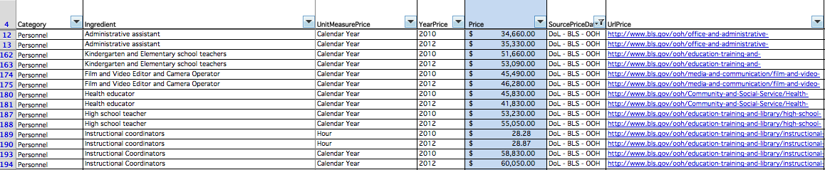

You will see the link for each ingredient under the UrlPrice column next to the SourcePriceData column. For the OOH, these links take you directly to the most recent price information. This is why the URLs for 2010 and 2012 are the same for any given ingredient.

Click on the link for the ingredient you want to update. For example, the link for “Administrative assistant” will open the page you see in Image 8. On this page you will be able to see the most recent median pay (i.e., “*$35,330*”).

*Image 8. Price Information in the OOH*

*[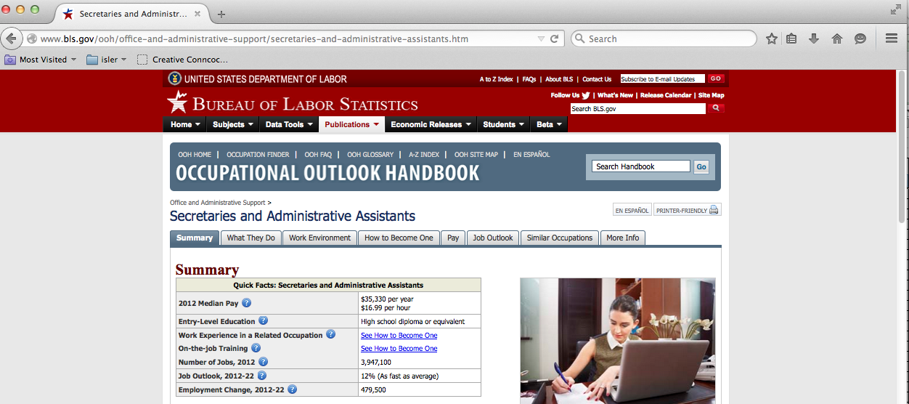](http://www.bls.gov/ooh/office-and-administrative-support/secretaries-and-administrative-assistants.htm)*

As summarized in Table 1, each ingredient has information such as Description Price, Mean/Median, Qualifications/experience, etc. in the database in addition to the price amount. While it is rare that the information about a given ingredient changes every year, it is important that you pay attention to these categories while updating a price. You can gather information on EdLevel, Sector, Mean/Median, Description of Ingredient, and Qualifications/Experience from the position’s page. Click on the “What They Do” tab for “Description of Ingredient” information (Image 9). Click on the “How to Become One” tab for information on “Qualifications/ Experience” (Image 10).

*Image 9. Finding Information on DescriptionPosition*

## [Macintosh HD:Users:ipekbakir:Desktop:Screen Shot 2015-03-12 at 1.25.19 PM.png](http://www.bls.gov/ooh/office-and-administrative-support/secretaries-and-administrative-assistants.htm#tab-2)

*Image 10. Finding Information on Qualification/Experience*

**[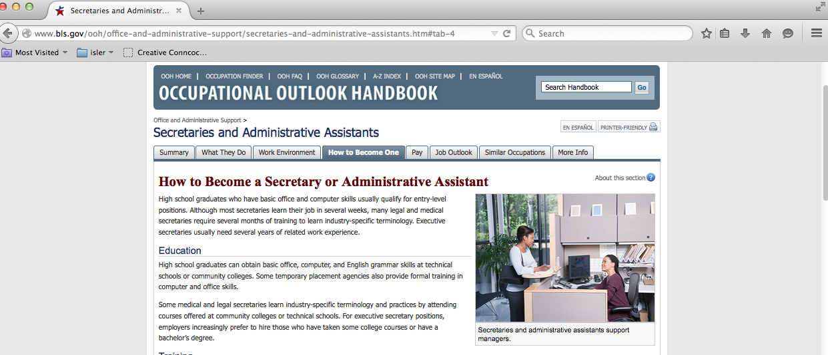](http://www.bls.gov/ooh/office-and-administrative-support/secretaries-and-administrative-assistants.htm#tab-4)**

The next step is to add the new price information into the database.

Find the ingredient you want to update in the database. Make sure that the database is not filtered by survey name (all filter functions must be off). Insert a new row below the ingredient that is being updated (right clicking on the row below the price you want to update, then “Insert”). As can be seen from Image 11, if you are adding a 2013 price for “Administrative assistant” go to the row showing the most recent price before 2013. Here, it is row 13 showing the 2012 price. Right click on the row below (row 14) to add a new line following the 2012 price (Image 12).

*Image 11. Adding a New Price*

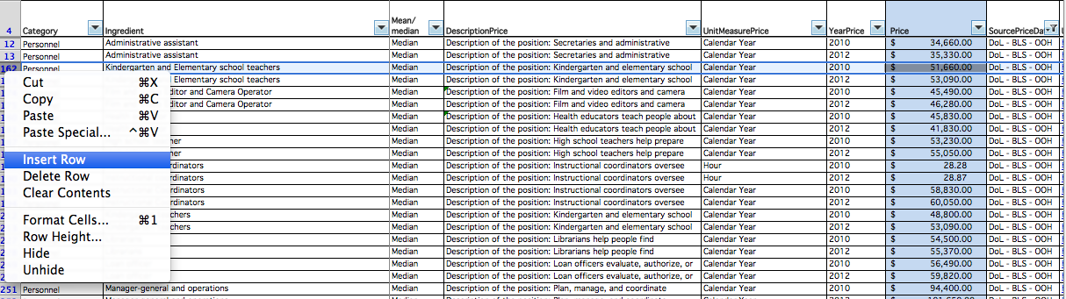

Image 12. Adding a New Price II

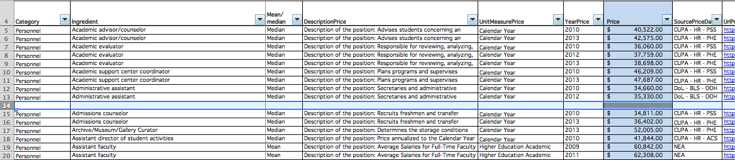

Add a new line for each new price and fill in the information you have found through the steps provided above under the corresponding columns. In most cases, the Price, YearPrice and SourcePriceData will be the only information that will change for every update. However, pay attention to all required fields while creating a new row since Description of Ingredient or other information may also change.

* 1. United States Department of Labor, Bureau of Labor Statistics- Occupational Employment Statistics Survey (DoL-BLS-OES)

The URL for [Occupational Employment Statistics](http://www.bls.gov/oes/home.htm) in Table 2 will open the homepage for the survey. Click on the “OES Data” tab (Image 13).

*Image 13. The OES Homepage*

[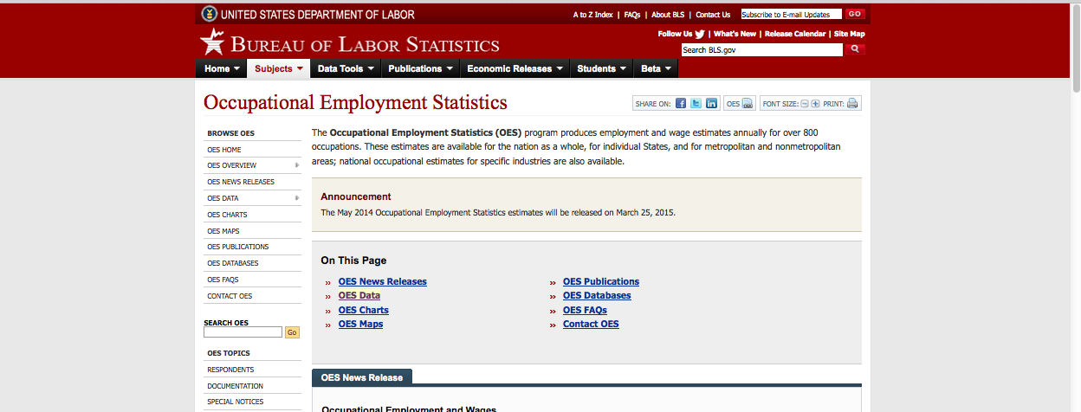](http://www.bls.gov/oes/home.htm)

Then click on “National (HTML)” to open the latest available survey (Image 14).

*Image 14. The Link to the Survey*

[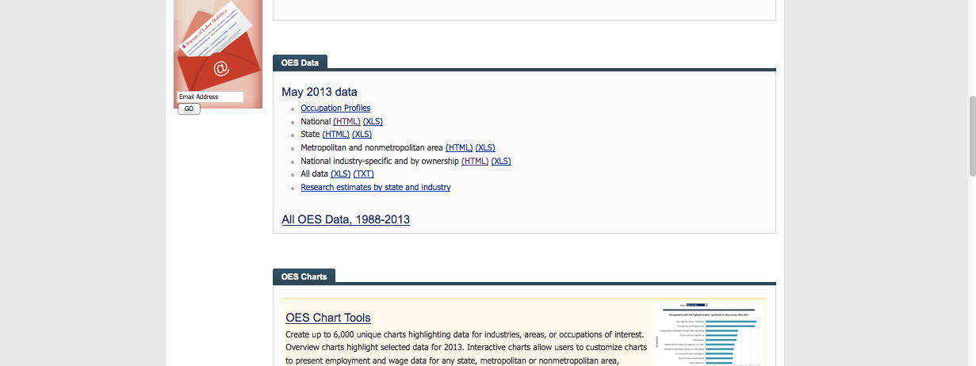](http://www.bls.gov/oes/#data)

All major groups for national occupational employment and wage estimates will appear on the homepage (Image 15).

*Image 15. All Major Groups for National Occupational Employment and Wage Estimates*

[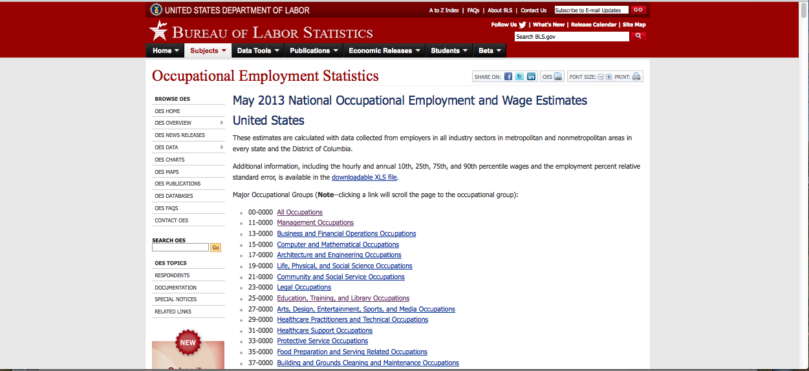](http://www.bls.gov/oes/current/oes_nat.htm)

Go to the database to see the ingredients prices taken from this survey by filtering the “SourcePriceData” for DoL-BLS-OES.

Go back to the survey page to search for the ingredient you want to find. For example, if you are looking for “Librarians,” CTRL + F🡪 type in “Librarians” on the survey page (Image 16). This simple search function will make it easier for you to find the ingredient you are looking for.

*Image 16. Finding a Price in the DoL-BLS-OES Survey*

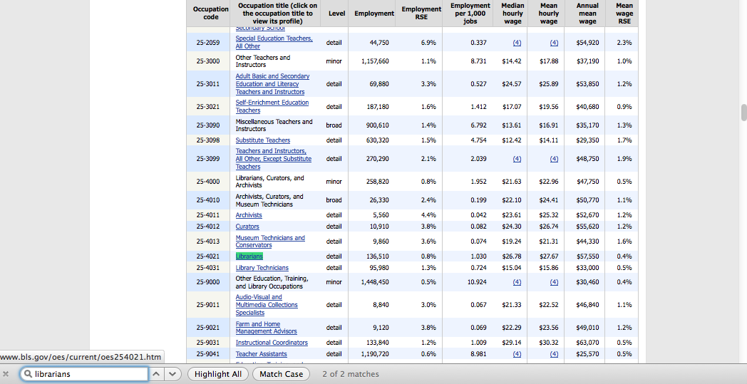

In this example, you can see the Mean hourly wage and the Annual mean wage come up next to the position title (“$27.67” and “$57,550” in Image 16).

As summarized in Table 1, each ingredient has information such as Description Price, Mean/Median, Qualifications/experience, etc. in the database in addition to the price amount. While it is rare that the information about a given ingredient changes every year, it is important to pay attention to these categories while updating a price. You can find detailed information on each position by clicking on the position title. For example, click on the “Librarians” title to go to the page with detailed information pertaining to Librarians (Image 17). You will find information on Description of Ingredient and Qualifications/Experience.

*Image 17. Detailed Information about the Position Title*

[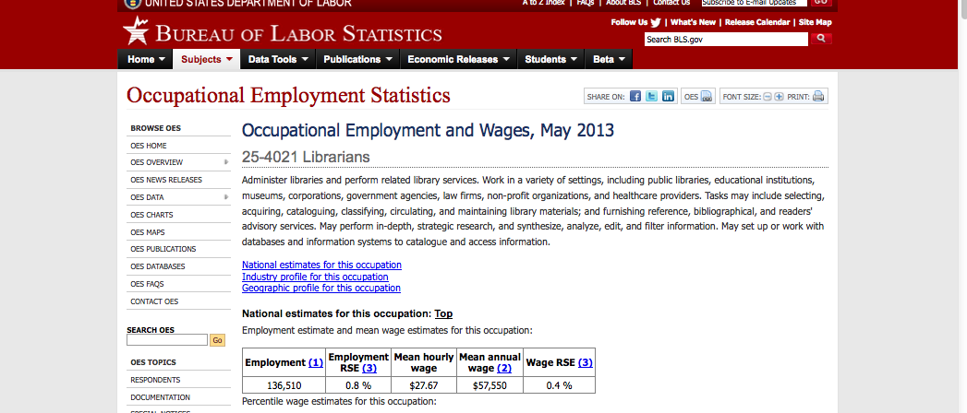](http://www.bls.gov/oes/current/oes254021.htm)

The next step is to add the new price information into the database.

Find the ingredient you want to update in the database. Make sure that the database is not filtered by survey name (all filter functions must be off). Insert a new row below the ingredient that is being updated (right clicking on the row below the price you want to update, then “Insert”). As can be seen from Image 18, if you are adding a 2014 price for “Librarians” go to the row showing the most recent price before 2014. Here, it is row 230 showing the 2013 price. Click on the row below (row 231) to add a new line following the 2013 price (Image 19).

Image 18. Adding a New Price I

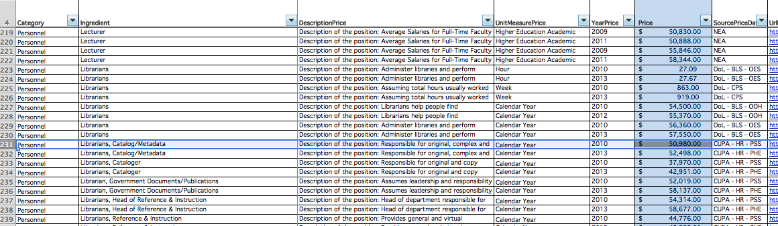

Image 19. Adding a New Price II

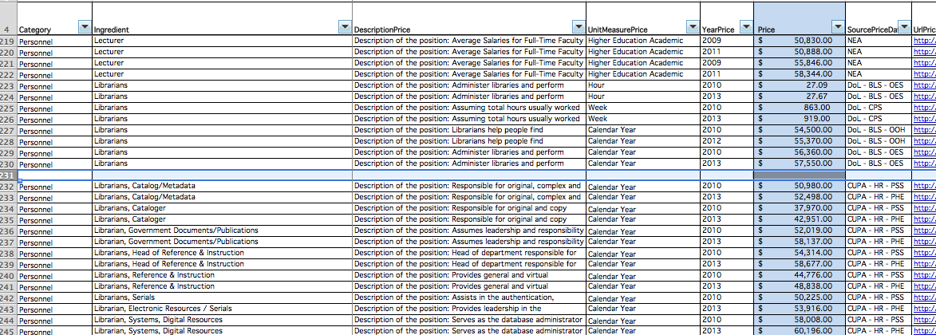

Add a new line for each new price and fill in the information you have found under the corresponding columns. In most cases the Price, YearPrice, and SourcePriceData will be the only information that will change for every update. However, pay attention to all required fields while creating a new row since Description of Ingredient or other information may also change.

* 1. Current Population Survey, Highlights of Women's Earnings (DoL-CPS)

The URL for the [Current Population Survey](http://www.bls.gov/cps/earnings.htm#demographics) in Table 2 will open the homepage for the survey. The CPS survey that we use for the CostOut database is the Annual Report on Highlights of Women’s Earnings report. Click on the year of the survey that you would like to view under the Annual reports (Image 20). For example, if you click on 2013, the report on BLS Highlights of Women’s Earnings in 2013 will open (Image 21).

*Image 20. CPS Homepage*

[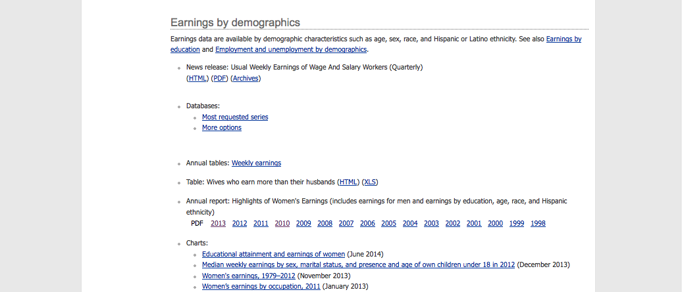](http://www.bls.gov/cps/earnings.htm#demographics)

*Image 21. Homepage for Highlights of Women’s Earnings in 2013*

[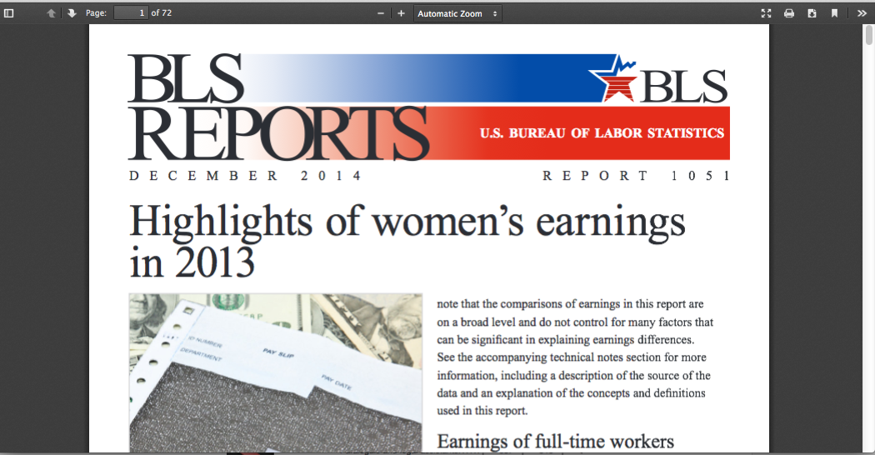](http://www.bls.gov/opub/reports/cps/highlights-of-womens-earnings-in-2013.pdf)

Go to the database to see the ingredients taken from this survey by filtering the “SourcePriceData” for DoL-CPS.

Go back to the survey page to search for the ingredient you want to find. For example, if you are looking for “Postsecondary teachers,” CTRL + F🡪 type in one key word “Postsecondary” on the survey page (Image 22). This simple search function will make it easier for you to find the ingredient you are looking for.

*Image 22. Searching for a Price in DOL-CPS*

[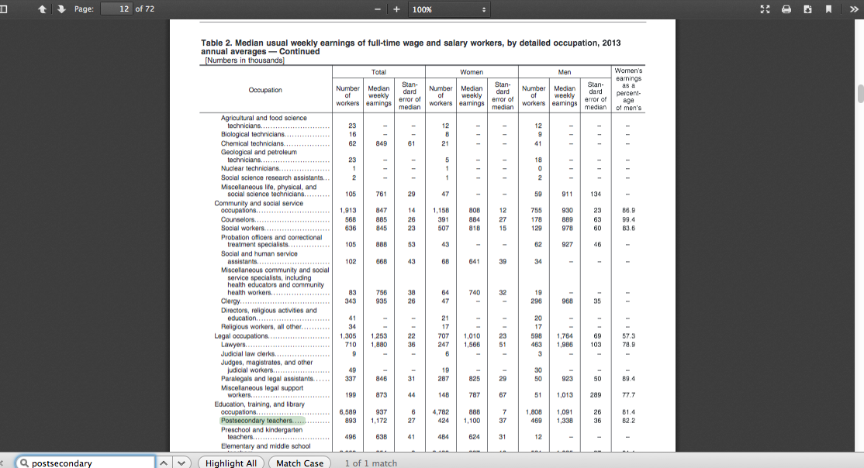](http://www.bls.gov/opub/reports/cps/highlights-of-womens-earnings-in-2013.pdf)

In this example, you can see the Median weekly earnings next to the position title, under the Total column (“$1,172” in Image 22).

As summarized in Table 1, each ingredient has information such as Description Price, Mean/Median, Qualifications/experience, etc. in the database in addition to the price amount. While it is rare that the information about a given ingredient changes every year, it is important to pay attention to these categories while updating a price. The Annual Report on Highlights of Women’s Earnings report does not, however, provide further information on Description of Ingredient or Qualifications/ Experience. While adding the updated price to the database, you can put “All states” or “All areas” since the Annual Report on Highlights of Women’s Earnings report is a national level survey that reports on prices representing all states and all areas.

The next step is to add the new price information into the database.

Find the ingredient you want to update in the database. Make sure that the database is not filtered by survey name (all filter functions must be off). Insert a new row below the ingredient that is being updated (right clicking on the row below the price you want to update, then “Insert”). As can be seen from Image 23, if you are adding a 2014 price for “Postsecondary teachers,” go to the row showing the most recent price before 2014. Here, it is row 295 showing the 2013 price. Right click on the row below (row 296) to add a new line following the 2013 price (Image 24).

*Image 23. Adding a New Price I*

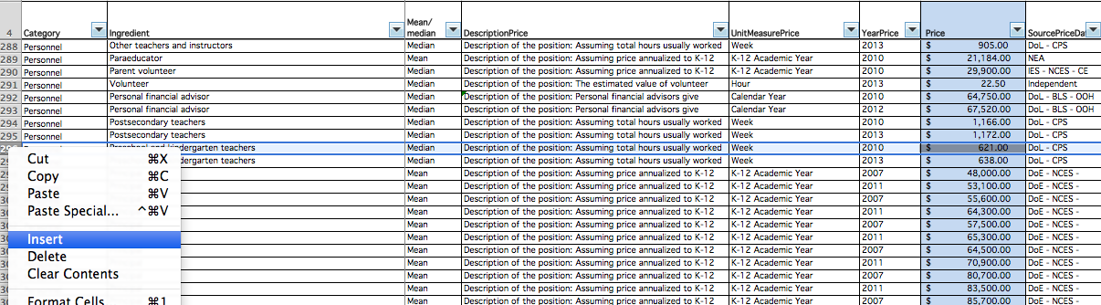

Image 24. Adding a New Price II

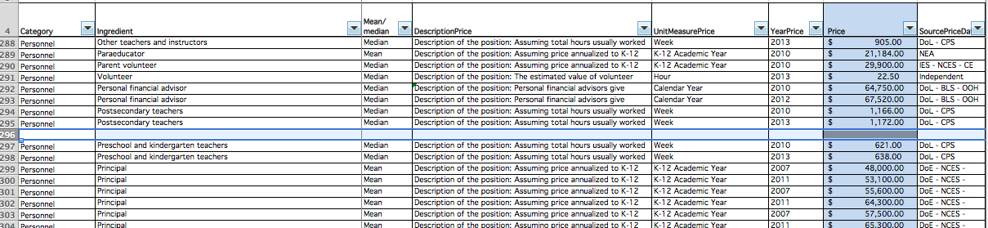

Add a new line for each new price and fill in the information you have found under the corresponding columns. In most cases, the Price, YearPrice and SourcePriceData will be the only information that will change for every update. However, pay attention to all required fields while creating a new row since Description of Ingredient or other information may also change.

* 1. Schools and Staffing Survey (DoE-NCES-SASS)

The URL for the [Schools and Staffing Survey](http://nces.ed.gov/surveys/sass/index.asp) (SASS) in Table 2 will open the homepage for the survey (Image 25). The ingredients for which we find prices from the SASS survey are principal and teacher salaries by years of experience and qualifications. The prices are found in two main reporting tables; one that reports on principals and another that reports on teachers. Each table can be found at a separate URL.

In order to find prices for principals, go to the SASS homepage (link provided in Table 2). In order to find new prices, click on “Tables by Year” under the Schools and Staffing Survey (SASS) window to choose the survey year you want to view (Image 26).

Image 25. Schools and Staffing Survey (SASS) Homepage

[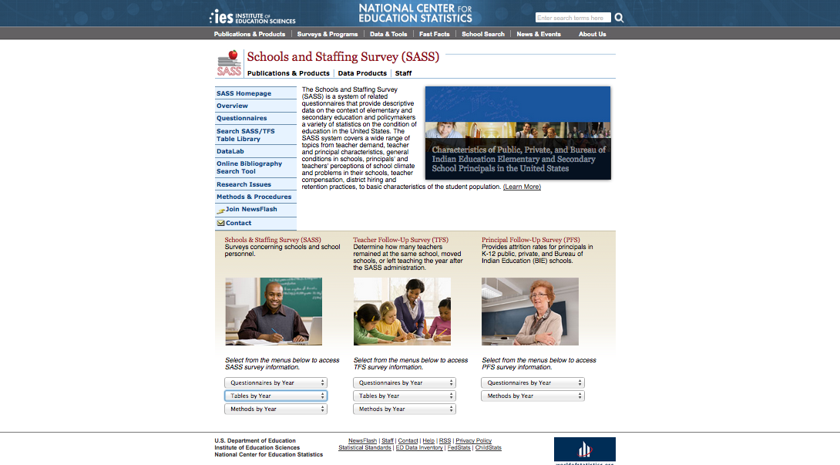](http://nces.ed.gov/surveys/sass/index.asp)

Image . Finding the Latest Survey

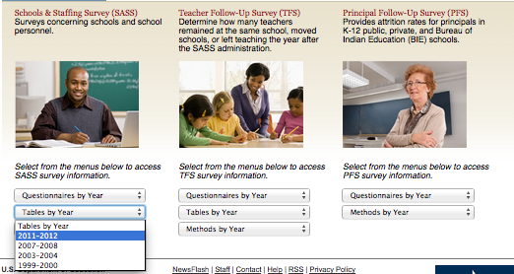

You will see the latest survey release year under the “Tables by Year” tab. Click on the most recent year, 2011-2012.

This will take you to the page with comprehensive list of all SASS tables (Image 27).

Image 27. List of all SASS Tables

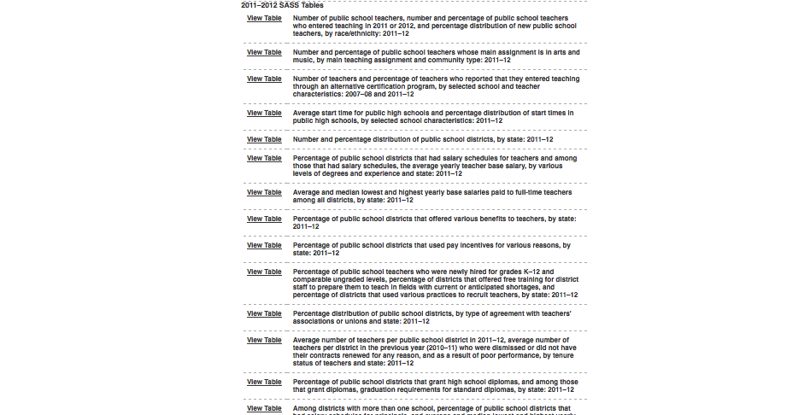

To find prices for *private* school principals, view the table titled “[Average annual salary for private school principals, by years of experience as a principal and affiliation: 2011–12.](http://nces.ed.gov/surveys/sass/tables/sass1112_2013313_p2a_004.asp)” To find prices for *public* school principals, view the table titled “[Average annual salary for public school principals, by years of experience as a principal and state: 2011–12.](http://nces.ed.gov/surveys/sass/tables/sass1112_2013313_p1s_004.asp)”

You can see the national average salary at the top of the table, given for three different levels of experience (Image 28).

*Image 28. Average annual salary for public school principals*

[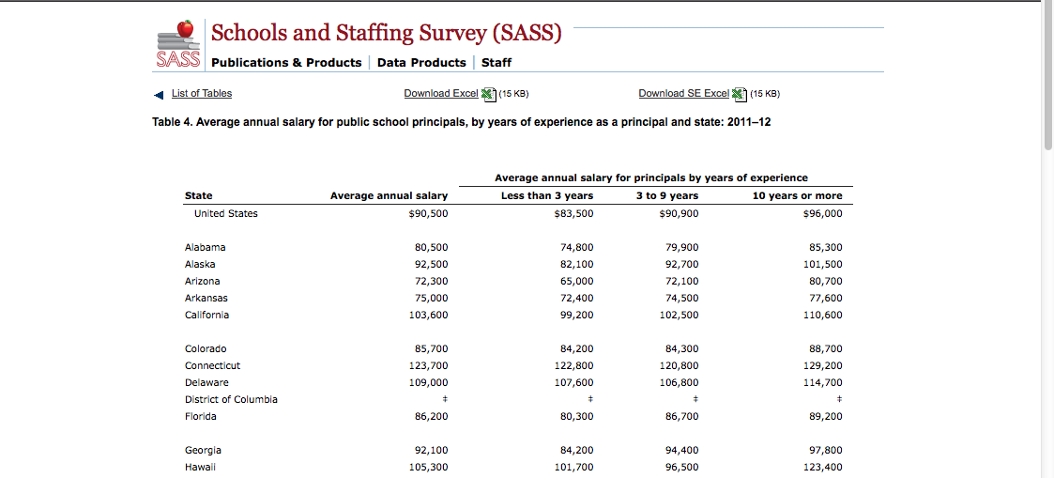](http://nces.ed.gov/surveys/sass/tables/sass1112_2013313_p1s_004.asp)

The second reporting table is for finding price information on teachers. The link for this is different from the SASS homepage, even though it is still part of the same survey.

Use the link <http://nces.ed.gov/programs/digest/> to open the homepage for Digest of Education Statistics. On the homepage, click on “Current” under List of Tables and Figures (Image 29).

*Image 29. Digest of Education Statistics Homepage*

*[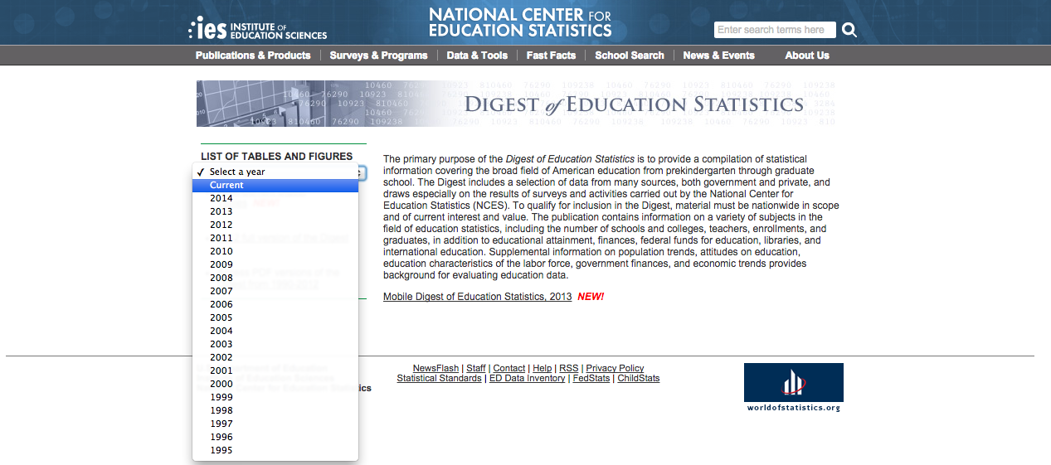](http://nces.ed.gov/programs/digest/)*

The list of most current digest tables will appear. Click on “Table 211.20. Average base salary for full-time teachers in public elementary and secondary schools, by highest degree earned and years of full-time teaching: Selected years, 1990–91 through 2011–12” (Image 30).

*Image 30. Average base salary for full-time teachers in public elementary and secondary schools, by highest degree earned and years of full-time teaching: Selected years, 1990-1991 through 2011-2012*

*[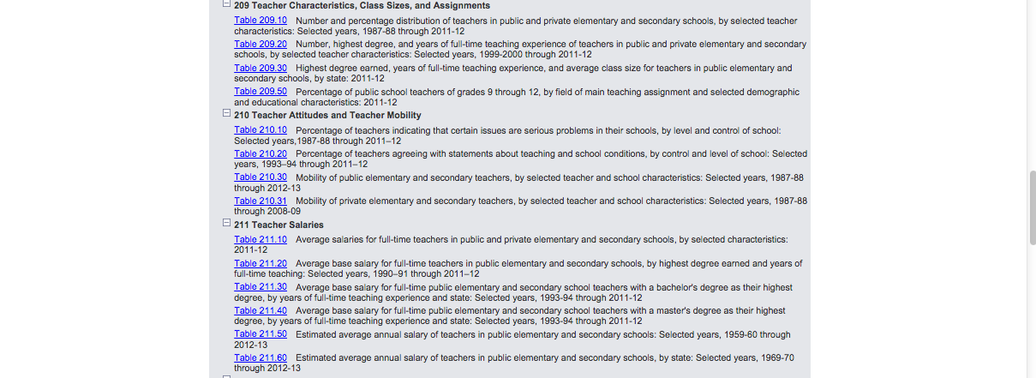](http://nces.ed.gov/programs/digest/current_tables.asp)*

Scroll down to the most recent year that shows teacher and teacher education specialist base salaries for teachers with varying qualifications and levels of experience (Image 31).

*Image 31. Average base salary for teachers with varying qualifications and level of experience*

[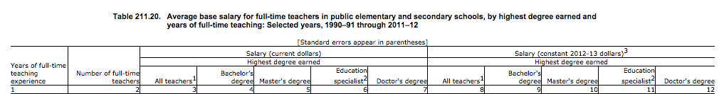](http://nces.ed.gov/programs/digest/d13/tables/dt13_211.20.asp)

## [Macintosh HD:Users:ipekbakir:Desktop:Screen Shot 2015-03-13 at 10.28.58 PM.png](http://nces.ed.gov/programs/digest/d13/tables/dt13_211.20.asp)

Find the price you are searching for under the Salary (current dollars) column. For example, a teacher with 4 years of experience and a Bachelor’s degree has an annual salary of $40,280; an education specialist with 15 to 19 years of experience will have an annual salary of $62,460.

As summarized in Table 1, each ingredient has information such as Description Price, Mean/Median, Qualifications/experience, etc. in the database in addition to the price amount. While it is rare that the information about a given ingredient changes every year, it is important to pay attention to these categories while updating a price. The information on principal experience is provided in the same reporting table as the prices (Image 28). Similarly, the information on Qualifications/ Experience for teachers is provided in the same reporting table as the prices (Image 31). Note, however, that the SASS does not provide further information on Description of Ingredient.

The next step is to add the new price information into the database.

Find the ingredient you want to update in the database. Make sure that the database is not filtered by survey name (all filter functions must be off). Insert a new row below the ingredient that is being updated (right clicking on the row below the price you want to update, then “Insert”). As can be seen from Image 32, if you are adding a 2013 price for “Principal (with <3 years of experience),” go to the row showing the most recent price before 2013. Here, it is row 299 showing the 2011 price. Right click on the row below (row 300) to add a new line following the 2011 price (Image 33).

*Image 32. Adding a New Price I*

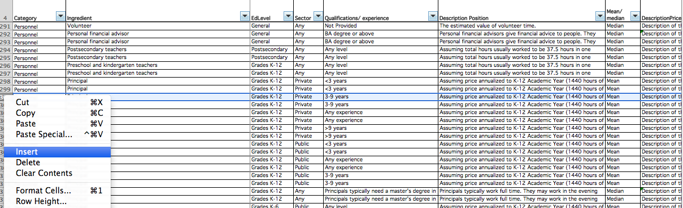

*Image 33. Adding a New Price II*

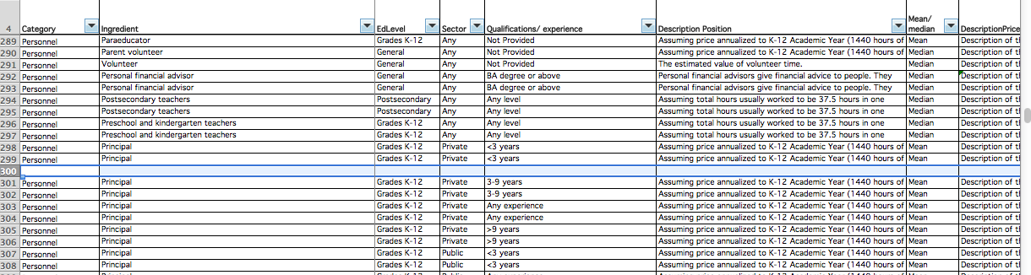

Add a new line for each new price and fill in the information you have found under the corresponding columns. In most cases, the Price, YearPrice and SourcePriceData will be the only information that will change for every update. However, pay attention to all required fields while creating a new row since Description of Ingredient or other information may also change.

* 1. National Teacher and Principle Survey (NTPS)

The URL for the National Teacher and Principle Survey (NTPS) in Table 2 will open the homepage for the survey (Image X). This survey replaced the SASS survey starting in 2015. The ingredients for which we find prices from the NTPS survey are principal and teacher salaries by type of school and school size. The prices are found in two main reporting tables; one that reports on principals and another that reports on teachers. Each table with salary information can be found at a separate URL.

In order to find prices for principals, go to the NTPS homepage (link provided in Table 2). In order to find new prices, scroll down until you see links to year specific reports for Teachers and Principles (Image 34).

*Image 34. National Teacher and Principle Survey homepage*

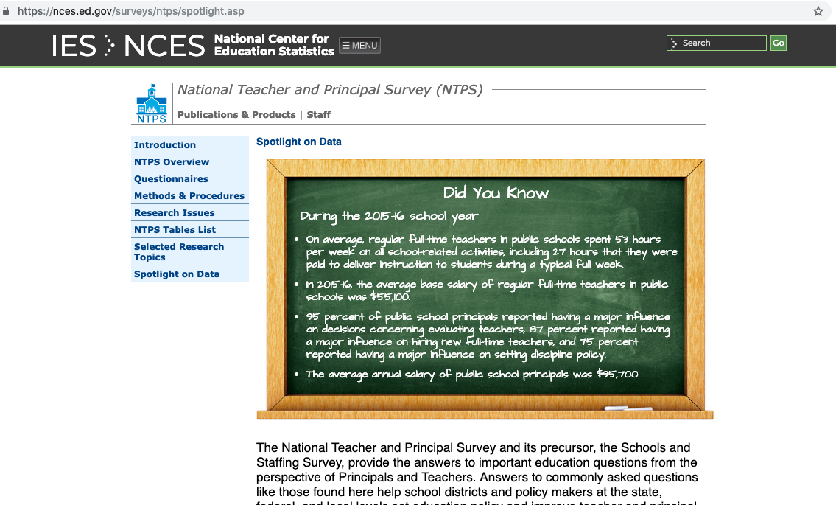

Select the report relevant to the salary you are looking for. To find the Teacher salary, select the most recent report (for 2015 the “2015-16 First Look” report was used). Click on the report (Image 35).

*Image 35. Bottom part of the National Teacher and Principle Survey homepage; section with access to year specific reports*

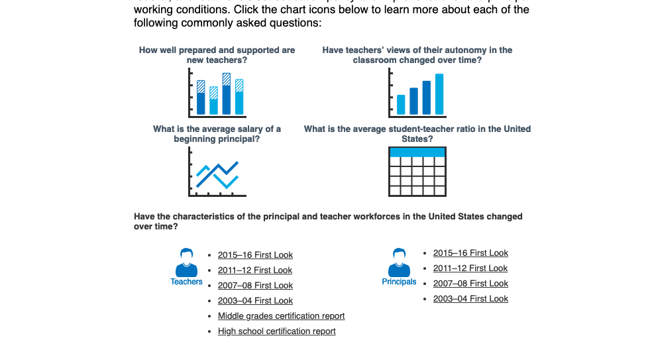

Once you open the report (Image 36), scroll down until you see the page with the “List of Tables” and look for the page number associated with the average annual salary table (Image 37).

Image . National Teacher and Principle Survey Principle Report



*Image 37. National Teacher and Principle Survey Principle “List of Tables”*

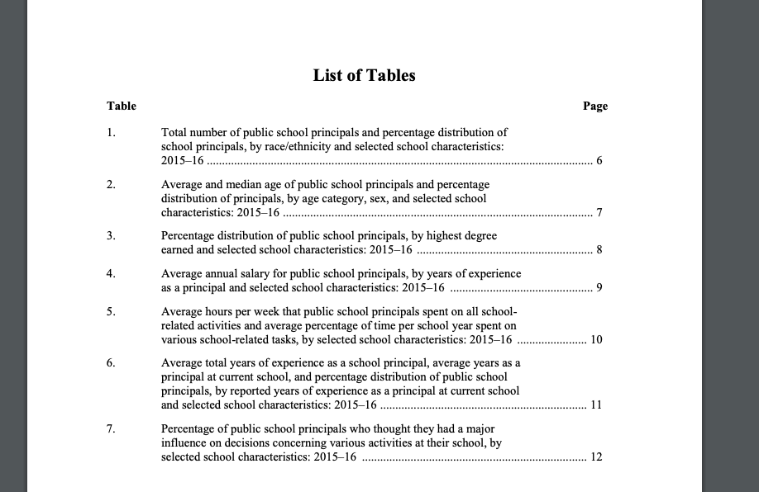

Scroll down until you find the correct table. Find the price you are searching for under the Average annual salary. For example, a principle working at a charter school has an annual salary of $88,000; a principl working at a school with 500-749 students enrolled will have an annual salary of $98,000 (Image 38).

*Image 38. National Teacher and Principle Survey Principle Report – Table with Salary Details*

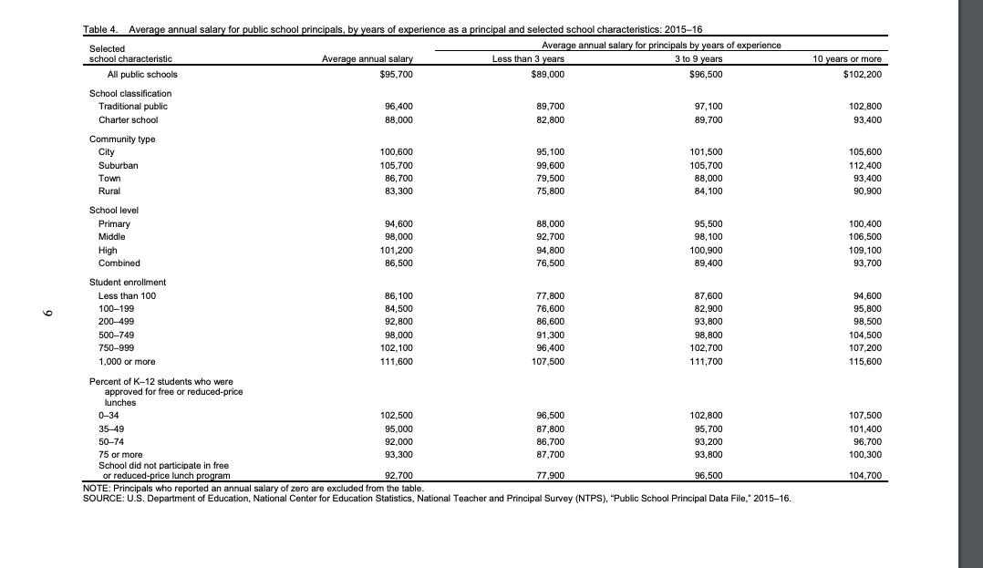

Add a new line for each new price and fill in the information you have found under the corresponding columns. In most cases the Price, YearPrice, and SourcePriceData will be the only information that will change for every update. However, pay attention to all required fields while creating a new row since Description of Ingredient or other information may also change.

* 1. OECD Education at a Glance Report (OECD-EG)

The URL for [OECD’s Education at a Glance](http://www.oecd-ilibrary.org/education/education-at-a-glance_19991487) in Table 2 will open OECD’s iLibrary homepage with all Education at a Glance reports (Image 39). Click on the most recent year of publication provided on the left side of the page. Click the READ button for the survey in order to access the report (Image 39, smaller red arrow).

*Image 39. OECD’s Education at a Glance iLibrary Homepage*

[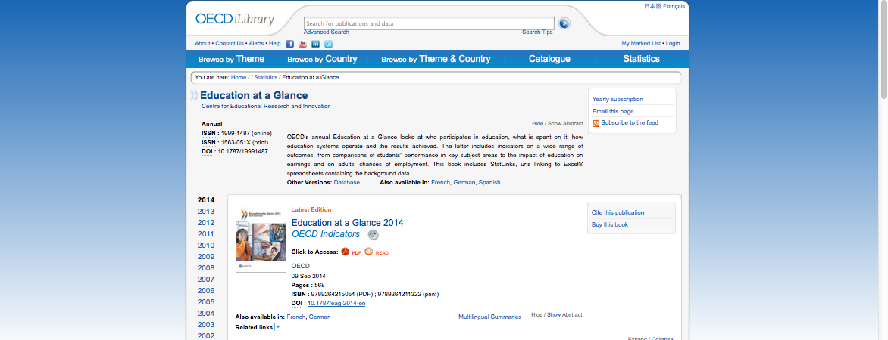](http://www.oecd-ilibrary.org/education/education-at-a-glance_19991487)

In the CostOut database, “Teacher” is the only ingredient that has price information from the OECD-EG. Once you open the readable version of the report, scroll down to the section titled “The Learning Environment and Organisation of School” in the Table of Contents (Image 40). Find the page number for the table titled “Teachers’ statuary salaries at different points in their careers” under the Indicator titled “How much are teachers paid?” In the 2014 report, this table is on page 467. Scroll down to page 467.

*Image 40. The Learning Environment and Organisation of School*

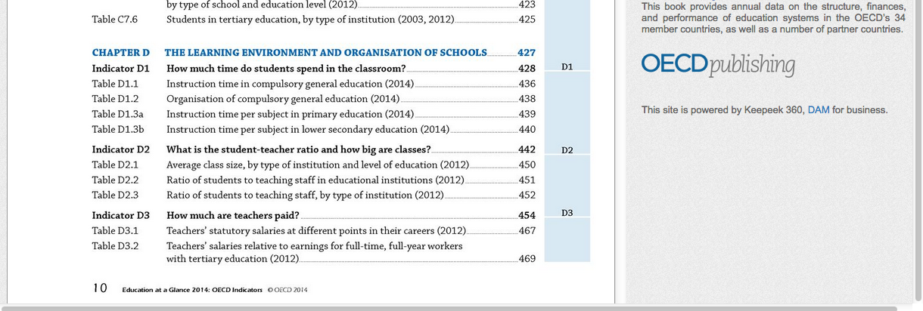

Find United States at the bottom of the table to see salaries for teachers with different levels of experience (Image 41).

*Image 41. Teacher salaries in the United States*

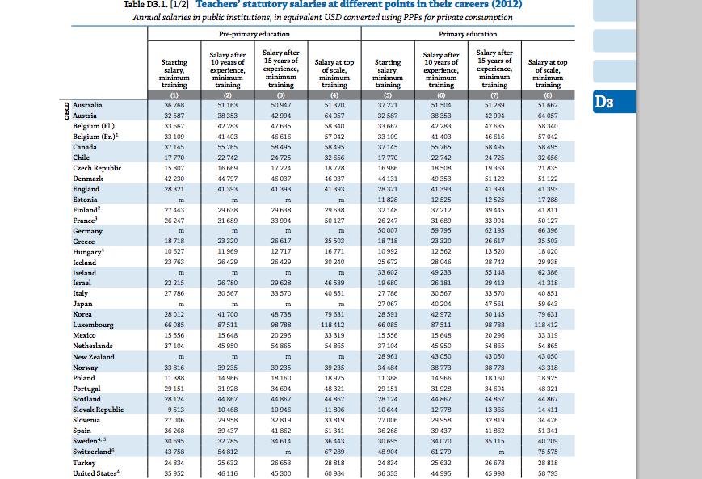

For example, if you are updating the price for pre-primary teachers with 10 years of experience and minimum training, the amount is “$46,116.” If you are updating the price for primary education teachers with salary at top of scale and minimum training the amount is “$58,793” (Image 41). Although most salaries shown in the OECD survey are statuary, the US numbers are actual base salaries for teachers, so we can use them in our database.

As summarized in Table 1, each ingredient has information such as Description Price, Mean/Median, Qualifications/experience, etc. in the database in addition to the price amount. While it is rare that the information about a given ingredient changes every year, it is important to pay attention to these categories while updating a price. The information on Teacher experience is provided in the same reporting table as the prices (Image 41).

The next step is to add the new price information into the database.

Find the ingredient you want to update in the database. Make sure that the database is not filtered by survey name (all filter functions must be off). Insert a new row below the ingredient that is being updated (right clicking on the row below the price you want to update, then “Insert”). As can be seen from Image 42, if you are adding a 2013 price for “Teacher (with minimum training, entry level)” go to the row showing the most recent price before 2013. Here, it is row 442 showing the 2012 price. Right click on the row below (row 443) to add a new line following the 2012 price (Image 43).

*Image 42. Adding a New Price I*

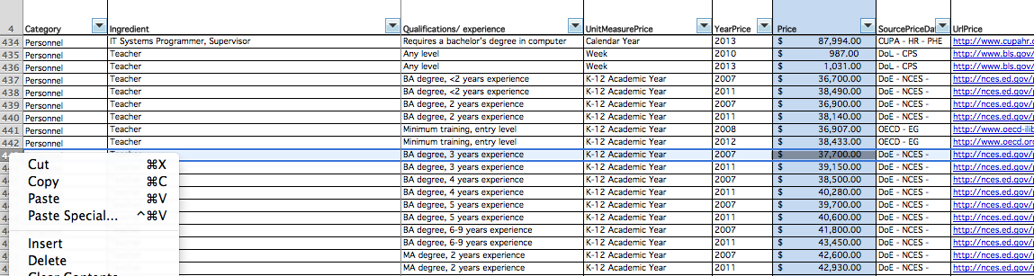

*Image 43. Adding a New Price II*

## Macintosh HD:Users:ipekbakir:Desktop:Screen Shot 2015-03-14 at 10.20.30 PM.png

Add a new line for each new price and fill in the information you have found under the corresponding columns. In most cases the Price, YearPrice, and SourcePriceData will be the only information that will change for every update. However, pay attention to all required fields while creating a new row since Description of Ingredient or other information may also change.

* 1. National Education Association (NEA)

The URL for the [National Education Association (NEA)](http://www.nea.org/home/44479.htm) in Table 2 will open the homepage for NEA’s Rankings of States and Estimates of School Statistics. Click on the most recent report that is available on the homepage (Image 44).

*Image 44. NEA homepage for Rankings of States and Estimates of School Statistics*

*[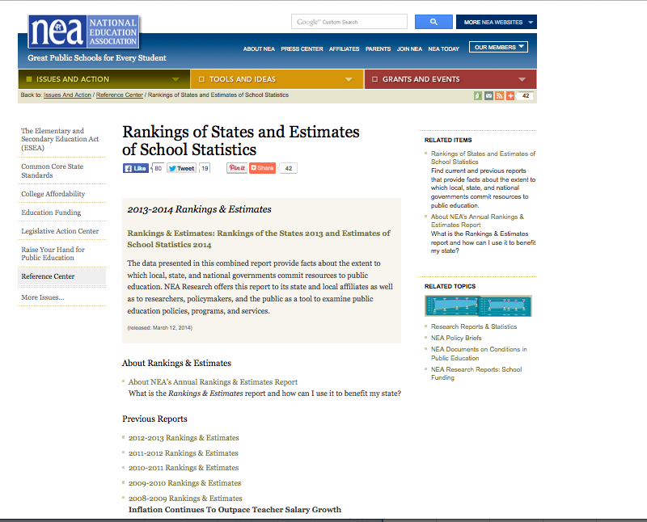](http://www.nea.org/home/44479.htm)*

Then, click the “Download the Full Report” link to download the PDF version of the survey (Image 45).

*Image 45. Rankings of States and Estimates of School Statistics in PDF*

[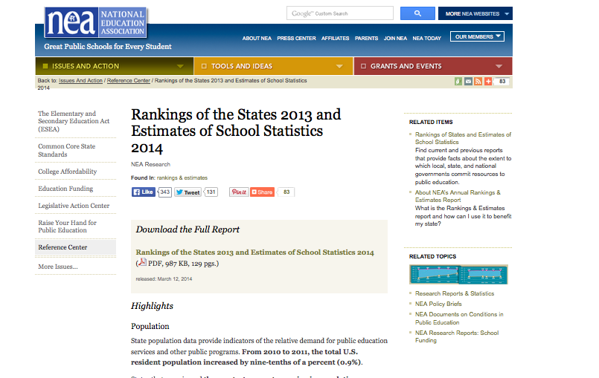](http://www.nea.org/home/rankings-and-estimates-2013-2014.html)

Before you start searching for ingredients in the PDF version of the report, go back to the database and determine the ingredients that are found in the NEA survey. Note that there are several URL sources for prices from NEA. This is because the database has used several different NEA surveys in the past. However, the only NEA survey that continues to be updated is the Rankings of the States and Estimates of School Statistics. Filter the SourcePriceData column in the database to show “NEA” and the “NextCheckDate” column to show “Predicted update March 2016” so that you can see the ingredients that are from the Rankings of the States and Estimates of School Statistics and are predicted to be updated. This should open three ingredients, “Teacher,” “Elementary School teachers” and “Instructional personnel (general).”

Go to the report that you opened in PDF and find the Highlights Table 1, as all three ingredients you are searching for have price information under this table. To do this, use CTRL + F🡪 and type in “Highlights Table 1” on the survey page (Image 46, large red arrow). Here, you can find the price information for “Teacher,” “Elementary School teachers” and “Instructional personnel (general)” under Average annual salaries ($) (Image 46, smaller red arrow).

*Image 46. Finding the “Highlights Table 1”*

*[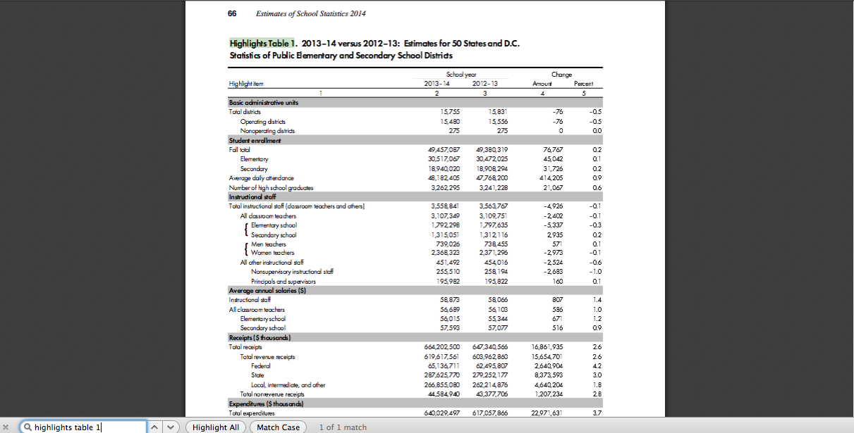](http://www.nea.org/assets/docs/NEA-Rankings-and-Estimates-2013-2014.pdf)*

For example, the average salary for Instructional Staff in the school year 2013-2014 was “$58,873.”

As summarized in Table 1, each ingredient has information such as Description Price, Mean/Median, Qualifications/experience, etc. in the database in addition to the price amount. While it is rare that the information about a given ingredient changes every year, it is important to pay attention to these categories while updating a price. Note that NEA’s Rankings of States and Estimates of School Statistics survey does not, however, provide further information on Description of Ingredient and Qualifications/experience.

The next step is to add the new price information into the database.

Find the ingredient you want to update in the database. Make sure that the database is not filtered by survey name (all filter functions must be off). Insert a new row below the ingredient that is being updated (right clicking on the row below the price you want to update, then “Insert”). As can be seen from Image 47, if you are adding a 2014 price for “Elementary school teachers,” go to the row showing the most recent price before 2013. Here, it is row 165 showing the 2013 price. Right click on the row below (row 166) to add a new line following the 2013 price (Image 48).

*Image 47. Adding a New Price I*

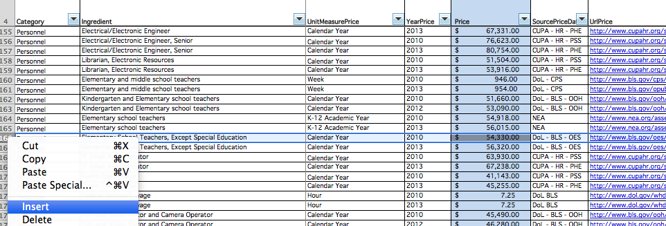

*Image 48. Adding a New Price II*

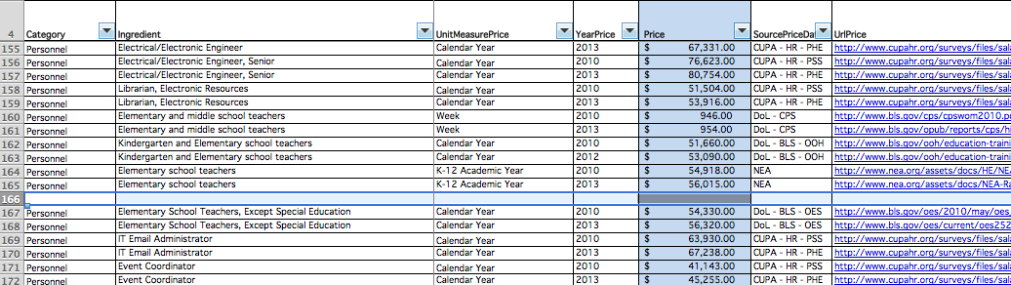

Add a new line for each new price and fill in the information you have found under the corresponding columns. In most cases the Price, YearPrice, and SourcePriceData will be the only information that will change for every update. However, pay attention to all required fields while creating a new row since Description of Ingredient or other information may also change.

* 1. Wage and Hour Division (DoL-BLS)

The URL for the [Wage and Hour Division](http://www.dol.gov/whd/state/stateMinWageHis.htm) in Table 2 is the direct link to the table showing the Changes in Basic Minimum Wages in Non-Farm Employment Under State Law (Image 49). In the database, the only price found in the Wage and Hour Division is the yearly federal minimum wage. Scroll down the page to find the most recent year. For example, the most recent year is 2013, and the Federal minimum wage amount is “$7.25” (Image 50).

*Image 49. Wage and Hour Division*

[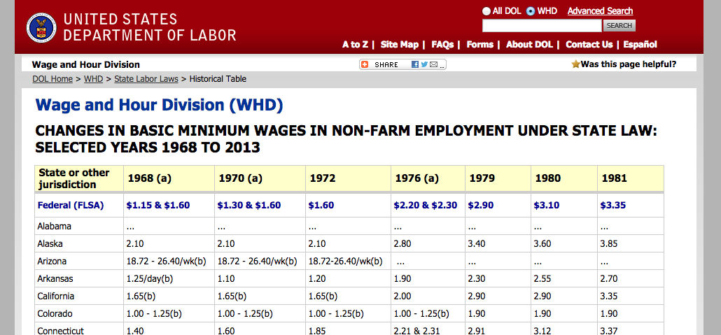](http://www.dol.gov/whd/state/stateMinWageHis.htm)

***Image 50. Most recent federal minimum wage***

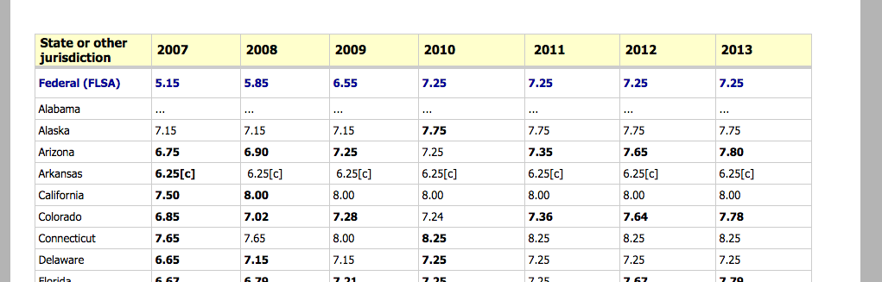

The next step is to add the new price information into the database.

Find “Federal minimum wage” in the database. Make sure that the database is not filtered by survey name (all filter functions must be off). Insert a new row below the ingredient that is being updated (right clicking on the row below the price you want to update, then “Insert”). As can be seen from Image 51, if you are adding the 2014 federal minimum wage, go to the row showing the most recent price before 2013. Here, it is row 174 showing the 2013 price. Right click on the row below (row 175) to add a new line following the 2013 price (Image 51).

*Image 51. Adding a new price*

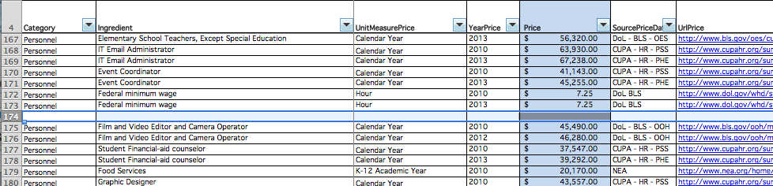

* 1. Additional Notes on Updating Prices
* Updating the “YearPrice” column may differ depending on how the survey conducts data collection. Some surveys, for example CUPA-HR, provide results in terms of academic year (i.e. 2010-2011 Academic Year) instead of one year (i.e. 2010). In these cases, put the initial year of the Academic Year (i.e., 2009 if 2009-2010) under the "YearPrice” column, instead of the year range.
* The “UnitMeasurePrice” differs for each survey. There are several measures that are used in our database, listed in Table 4 below.

*Table 4. Hour equivalencies for different price units found in price surveys and CostOut database*

|  |  |
| --- | --- |
| UnitMeasurePrice Units | Equivalency in hours |
| Hour | 1 |
| Day | 8 ( 8 hours a day) |
| Week | 40 (5 days a week, 8 hours a day) |
| Calendar year | 2080 (52 weeks, 5 days a week, 8 hours a day) |
| K-12 academic year | 1440 (36 weeks, 5 days a week, 8 hours a day) |
| Higher education academic year | 1560 (39 weeks, 5 days a week, 8 hours a day) |

Some surveys provide detailed information on how they measure annual salary in terms of total weeks, hours, or months. Other surveys do not provide the specifics of their price measure. The current “UnitMeasurePrice” for each survey in the CostOut database has been determined after careful research of each survey methodology. Therefore, make sure that the updated prices follow the same measure as previous prices from the same survey unless otherwise indicated in the technical notes section of the survey.

* Furthermore, make sure you account for the UnitMeasurePrice you assign to a given price by including information on its equivalency in hours under the “Description of Ingredient” column (Image 52).

*Image 52. Adding Information about UnitMeasurePrice*

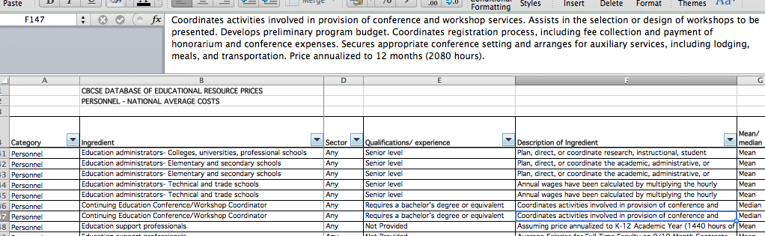

1. Updating Benefits

*CostOut* also provides some possible benefit rates to add to the personnel wages. The benefit rates used are the employee benefits in the United States reported by the Bureau of Labor Statistics (BLS) (<http://www.bls.gov/news.release/ecec.t04.htm>). The benefit rates include medical benefits, retirement benefits, paid sick-leave benefits, legally required benefits, and supplemental pay. ***Note that CostOut shows benefits as a percentage of total salary, not a percentage of total compensation.*** If a survey reports the latter, we describe how to convert it to the former below.

The CostOut database of benefits is a short list of 50 items and should be updated annually. Check the LastCheckDate column in the Benefits sheet to determine the last time the rates were updated.

Click on <http://www.bls.gov/news.release/ecec.t04.htm> and scroll down to the table showing benefit rates as percent of total compensation under the column “Total” benefit costs for occupational or industry group (Image 53).

*Image 53. Percent of total compensation table*

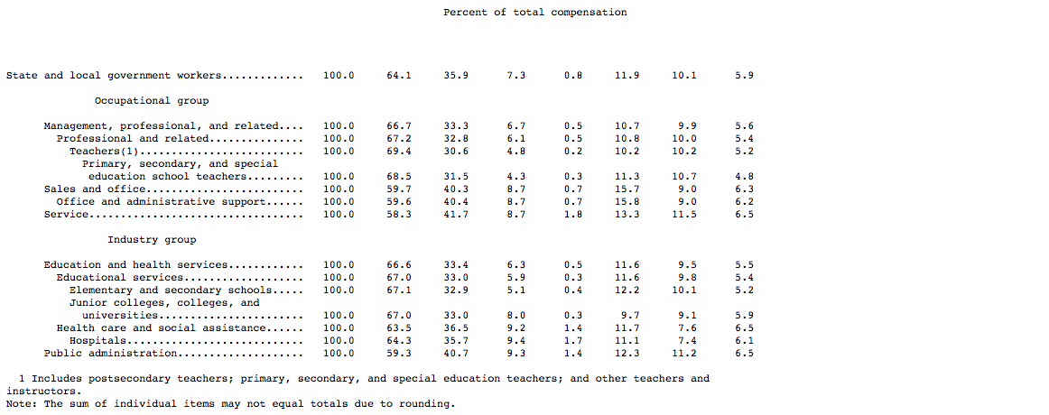

The BLS reports these benefit rates as a percentage of total compensation even though most people present benefit rates as a percentage of wages. Before updating the benefits rate in the database, you will have to convert the benefit rates from BLS using the formula presented below.

**The formula used to adjust wages (W) to include benefits (B) in order to calculate total compensation (TC) is:**

$$B=TC/(1-benefit as \% of TC)$$

***For example, the benefits rate as percentage of total compensation (TC) for all educational services employees is 33.0%:***

***Benefit % = 0.33/ (1- 0.33)***

***= 0.471***

***= 47.1%***

The next step is to add the adjusted benefits rate into the database.

Find the rate you want to update. Insert a new row below the ingredient that is being updated (right clicking on the row below the price you want to update, then “Insert”). As can be seen from Image 54, if you are adding the 2015 benefits rate for “Civil workers: Educational services” go to the row showing the most recent benefits rate before 2015. Here, it is row 9 showing the 2014 rate. Right click on the row below (row 10) to add a new line following the 2014 rate. Note: The new rates have to be added manually with no more than two decimal places.

*Image 54. Adding New Benefits Rate*

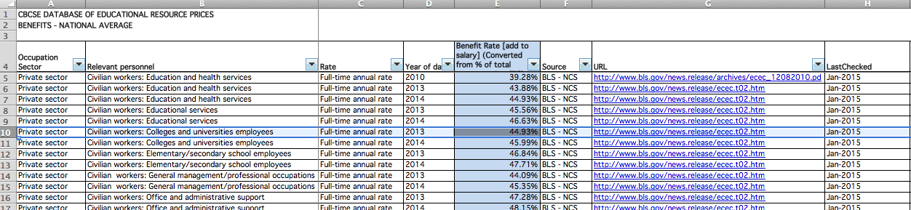

Upload the updated benefits database into *CostOut* using the Demo admin account. Make sure the file is saved as “Database of Benefits Rates.xls” before you upload it otherwise it will not replace the existing file.

1. Formatting Guidelines for the Online CostOut Database of Educational Resource Prices

Once you have finished updating prices in the Excel-based CostOut Database of Educational Resource Prices (the “database”), the database needs to be formatted correctly for uploading into *CostOut* [www.cbcsecosttoolkit.org](http://www.cbcsecosttoolkit.org) via the administrator (**Admin**) interface. If you have not changed the format since downloading the latest version, you do not need to re-format. Only CostOut personnel should have access to perform these functions. The database should be updated and uploaded periodically, for example, after the seven survey release dates in February and March, again after the one September survey release date, and again after the five November and December survey release dates. You can find the most recent version of the database in *CostOut* in the **Upload Files** page which lists all uploaded files and allows you to download the current version for use and editing. Come back to this same page for uploading. After uploading the updated database, click on **Import to Database tables** and select **Import Prices Database**.

* 1. Saving the Database Files Before Formatting

First, save the CostOut Database of Educational Resources as “**DBofPrices.xlsx”** before making any changes on the worksheets. Make sure that the document is saved in .*xlsx* format. Go to File > Properties > General to make sure that the extension on the file is *.xlsx* (Image 1A).

*Image 1A. Saving the database*

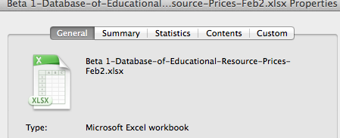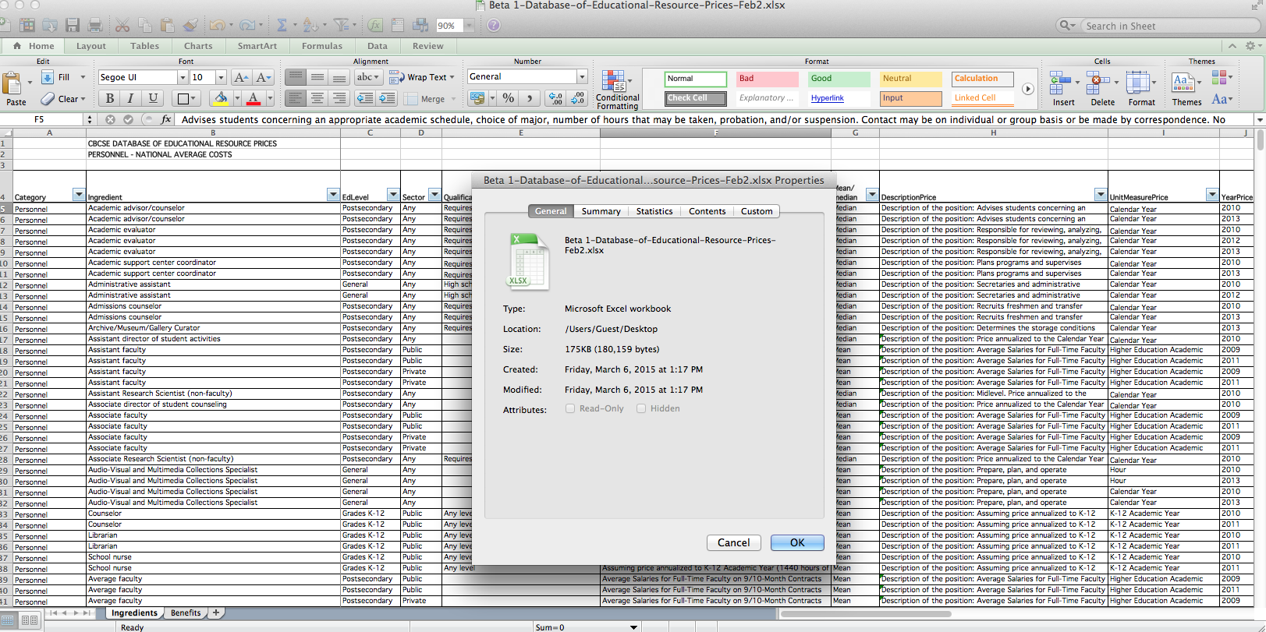

Note that we keep one Excel workbook with the ingredients prices and one for benefits rates. Each of these workbooks should be kept as separate files (Image 2A). They cannot be kept as separate worksheets in the same workbook. The name of the sheet with the Ingredients must be named “Ingredients” and similarly, the sheet with Benefits must be named “Benefits.”

*Image 2. Saving the correct Excel sheets*

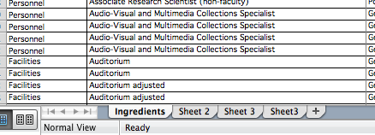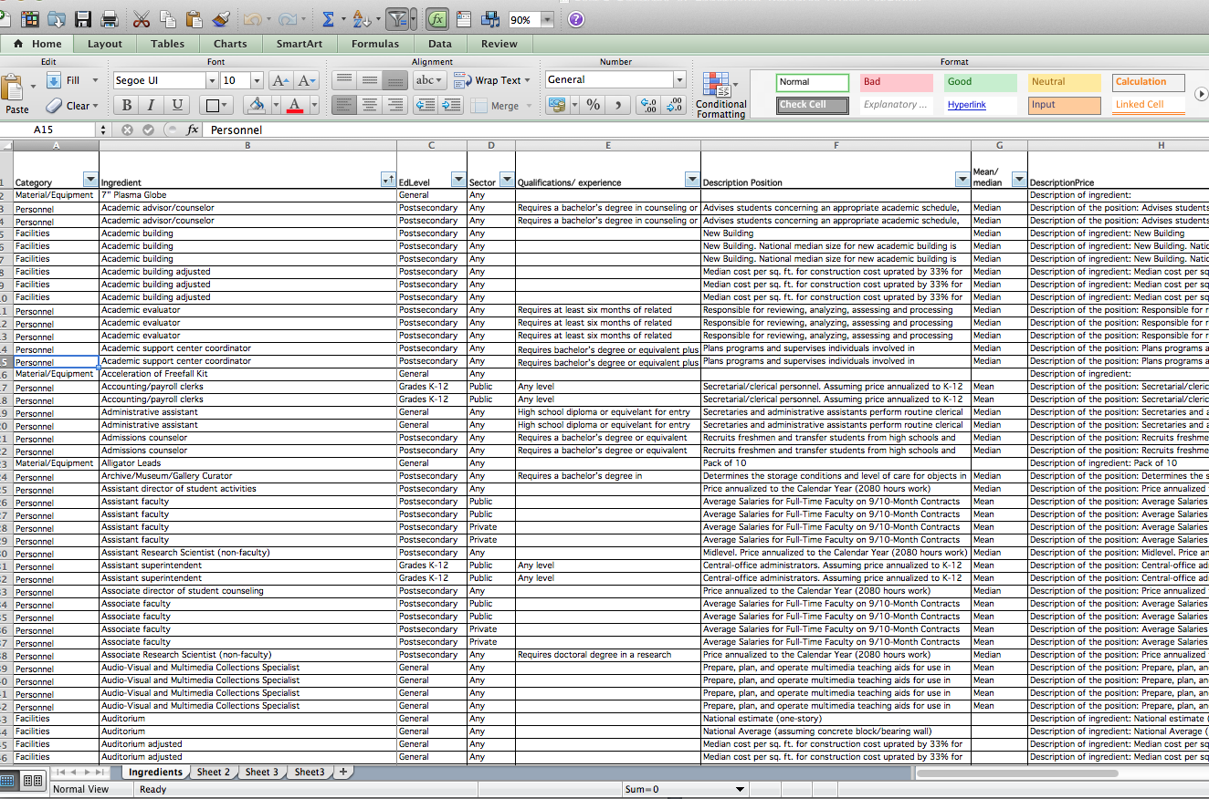

You should have two separate documents saved, one for the Ingredients worksheet - “DBofPrices.xlsx” - and another one for the Benefits worksheet – “Database of Benefits Rates.xls”.

* 1. Deleting Extraneous Cells

Delete any rows above the row with the column titles so that the first row shows column titles (Image 3A).

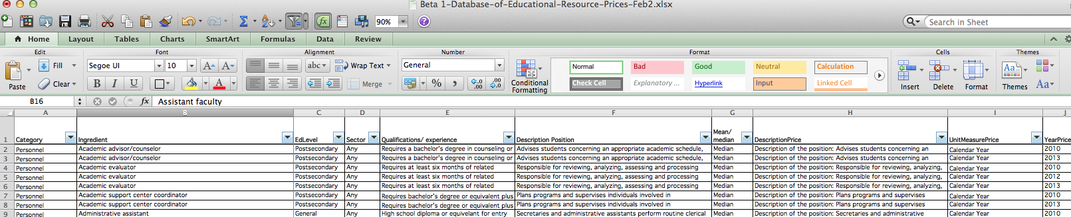*Image 3A. Column titles in the first row*

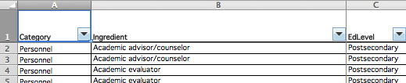

The online CostOut Tool Kit does not recognize empty cells. Therefore, check for and delete any empty rows in the database (Image 4A).

*Image 4A. Delete empty rows*

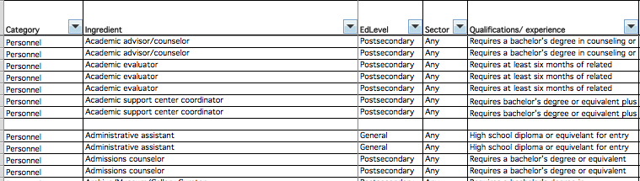

* 1. Change the database to show values

In order for the online CostOut database to show the information the way it appears in the Excel version of the database, the cells must be edited to show values rather than formulas. In order to do this, select and copy all cells (CNTRL + A and CNTRL+C ). Then click on the Paste Special tab in the left hand corner, and select “Values” to paste the copied cells as Values over the top of the same cells (Image 5A).

*Image 5A. Paste as values rather than formulas*

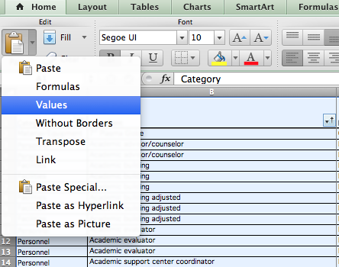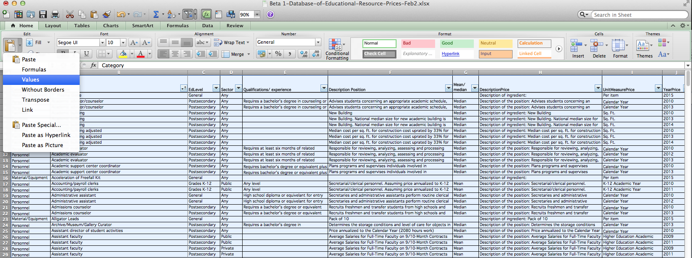

* 1. Delete columns that are not needed

If the Excel-based database you are using has separate columns entitled “Qualifications/Experience,” “Description of Ingredient,” and “Mean/Median,” they will need to be combined to create a new column, “DescriptionPrice.” In older versions of the database, we kept these columns separate before uploading so that it is easy to enter the information required for each column. The version to be uploaded should only have the “DescriptionPrice” column. If for any reason you are using an older version of the database, once the cells show values, you can delete the three columns (Image 6A).

*Image 6A. Delete columns*

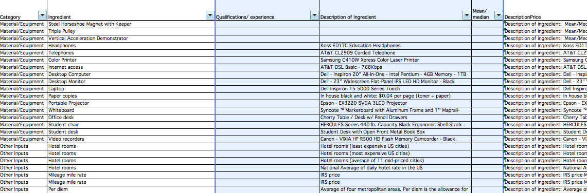

* 1. Make sure that the column titles are correct

The column titles in the Excel version of the database must match the column titles in the online CostOut Database of Educational Prices. Below you can find two tables showing the column titles that the Excel version of the database should have before being uploaded to the online tool. The first table shows the column headings for the Ingredients worksheet and the second one shows the column headings for the Benefits worksheet.

Ingredients Column Headings: Benefits Column Headings:

|  |  |
| --- | --- |
| Column A1 | PriceProvider |
| Column B1 | Category |
| Column C1 | Ingredient |
| Column D1 | EdLevel |
| Column E1 | Sector |
| Column F1 | DescriptionPrice |
| Column G1 | UnitMeasurePrice |
| Column H1 | Price |
| Column I1 | YearPrice |
| Column J1 | StatePrice |
| Column K1 | AreaPrice |
| Column L1 | SourcePriceData |
| Column M1 | UrlPrice |
| Column N1 | LastChecked |
| Column O1 | NextCheckDate |

|  |  |
| --- | --- |
| Column A1 | SectorBenefit |
| Column B1 | PersonnelBenefit |
| Column C3 | TypeRateBenefit |
| Column D1 | YearBenefit |
| Column E1 | BenefitRate |
| Column F1 | SourceBenefitData |
| Column G1 | URLBenefitData |
| Column H1 | LastChecked |
| Column I1 | NextCheckDate |

* 1. Additional Information on formatting the workable Excel version of the database
     1. Combining three columns to create new “DescriptionPrice” column:

In the Ingredients Workbook, three of the columns should be combined (or “concatenated”) into one column before uploading. This should already be done but instructions are provided here in case of need.

The columns in the Excel-based database entitled “Qualifications/Experience,” “Description of Ingredient,” and “Mean/Median” are combined to create a new column, “DescriptionPrice.” We keep these columns separate before uploading so that it is easy to enter the information required for each column. The version to be uploaded to CostOut should only have the “DescriptionPrice” column.

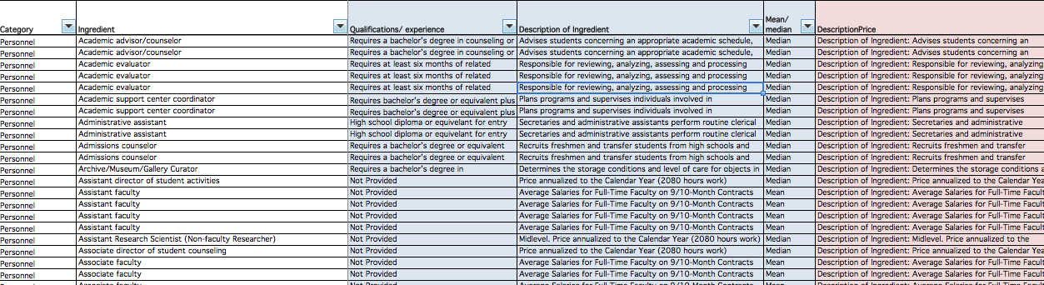

The formula used for combining the information is saved into the database. Therefore, you will not have to re-enter it while updating the database. However, in case you need the formula at some point or if the formula gets deleted from the system, this section explains how to concatenate columns.

The formula to combine the information in the three columns, “Qualifications/ Experience,” “Description of Ingredient,” and “Mean/ Median,” into one column is as follows (note: keep all spacings and punctuation exactly as shown as this determines how the data is shown in the database):

=IF(A2="Personnel",CONCATENATE("Description of Ingredient: ",F2,"

", "Qualifications/ experience: ", E2,"

","Mean/ Median: ",G2),CONCATENATE("Description of Ingredient: ",F2,"

","Mean/ Median: ",G2))

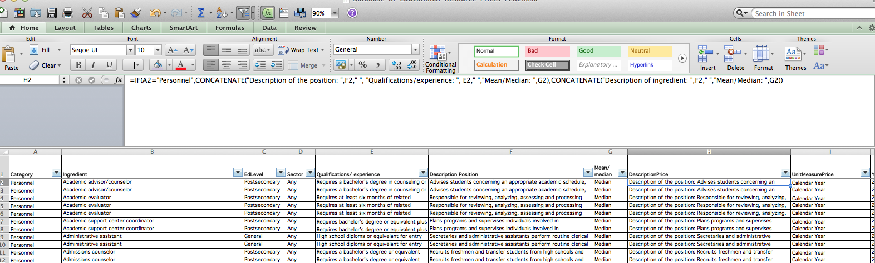This formula should be entered in the first row under the column heading “DescriptionPrice.”

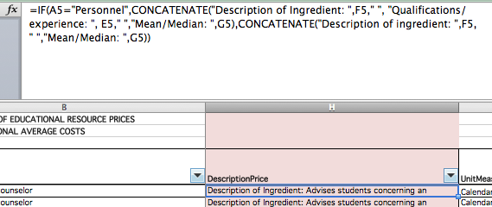

The “=CONCATENATE” formula is used for combining values in multiple cells into one cell. The formula has been written to be conditional on whether the information we need to combine is for a Personnel ingredient. Facilities, Materials and Equipment, and Other ingredients do not have the column “Qualification/ experience.”

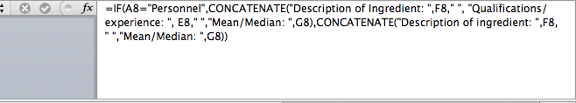

In the above formula, we are stating that “If the cells that are being concatenated are in the “Personnel” category (A2), then combine “Description of Ingredient” (F2), “Qualifications/ experience” (E2), and “Mean/ Median” (G2). If, however, the cells are not in the Personnel category, then only concatenate “Description of Ingredient” (F2) and “Mean/ Median” (G2). In order for each of the 3 items to appear on a new line in the combined cell, use Alt Enter after the cell location of each column heading (i.e., after F2,” and after E2,”) when writing the formula.

Lastly, make sure that each row under DescriptionPrice has the concatenate formula. Copy and paste this formula using the Paste Special + Formula option.

---------------------------------------------------------

***Reference***

Levin, H. M., & McEwan, P. J. (2001). C*ost-effectiveness analysis: methods and applications* (2nd ed.). Thousand Oaks, CA: Sage Publications.